MUJTABA SHAHID FAIZI
BSCS-5A
131818
LAB 2 OF OS

TASK 1
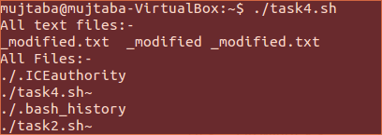

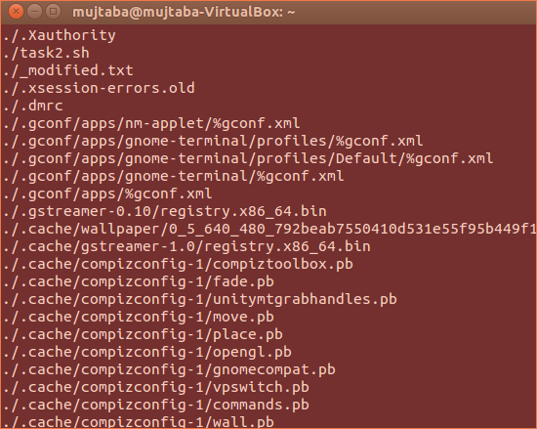

echo "All text files:-"
ls *.txt #shows all text files
echo "All Files:-"
for entry in * #shows all files
do
echo $entry

TASK 2

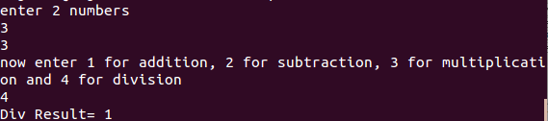
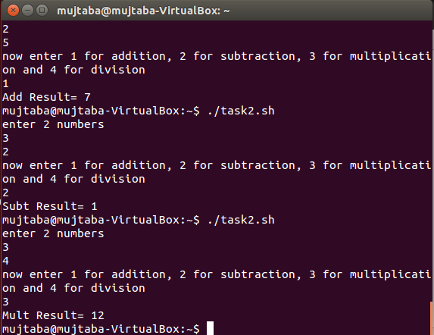

echo "enter 2 numbers"
read a #reading 2 numbers for operation
read b
echo "now enter 1 for addition, 2 for subtraction, 3 for multiplication and 4 for division"
read c
case $c in #using a number to run a perticular condition of operation
1)echo "Add Result=" `expr $a + $b`;; #applying operations
2)echo "Subt Result=" `expr $a - $b`;;
3)echo "Mult Result=" `expr $a \* $b`;;
4)echo "Div Result=" `expr $a / $b`;;
*)echo "Invalid operation";; #if other than 1,2,3 or 4 entered
esac

Task 3:

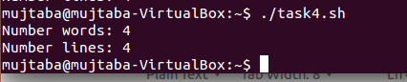

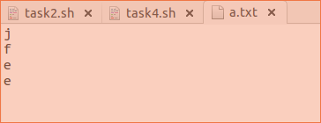

words=0
lines=0
while read line
do
lines=`expr $lines + 1` #increments everytime a new line is encountered
words=`expr $(IFS=''; set -- $line; echo $#) + $words`

done<"a.txt"

echo "Number words: $words"
echo "Number lines: $lines"

Task 4:

This script removes everything in a text file thats in parenthesis and saves in a new file.

